COM00141M

Department of Computer Science

ALGORITHMS AND DATA STRUCTURES

EXAMINATION PRE-WORK



| **Author** | Dr Nurdan Cabukoglu |
| --- | --- |
| **Assessment type** | Pre-Work for Exam |
| **Release** | Monday, Week 8 at 13:00 (1pm), UK time * |
| **Submission** | This work is not submitted directly, except where it is required as part of an exam question. |
| **Feedback** | Feedback will not be provided on this work directly, except where it is required as part of an exam question. |
| **Weighting** | Around 50% of the exam questions will be based on this work. |

* If this date falls on a UK public holiday or a University of York closure day, the submission date will change. Please check the submission point in the ‘Assignments’ area of the module in Canvas for the exact submission deadline. Release dates will not change.

# Module Learning Outcomes

The module learning outcomes (MLO’s) for this module are as follows:

**MLO 1.** Express a problem solution algorithmically using pseudocode.

**MLO 2.** Analyse the time complexity of an algorithm.

**MLO 3.** Construct computer programs to implement algorithms.

**MLO 4.** Test a computer program against the specification.

This pre-work will contribute to the learning outcomes MLO 1 and MLO 4 via the examination questions.

# Assessment Background/Scenario

## A private company aims to identify the least-cost healthy diet per day for five countries: the UK, France, Germany, Italy, and Spain. The food prices for these diets consider the least-cost combination of locally available foods to meet the needs of a representative adult requiring 2,330 kcal per day, at three levels of diet quality: a healthy diet, a nutrient-adequate diet, and an energy-sufficient diet. The initial results for these five countries are based on the national average prices in 2017. The cost per person, per day, of the different food groups in a healthy diet for each country is provided in Table 1, and the share of each food group is provided in Table 2.

#### *Diet cost*

* Cost of a healthy diet, per person, per day;
* Cost of a nutrient adequate diet, an energy sufficient diet per person per day (Table 1)
* The share of the different food groups per person per day: fruits, vegetables, animal-sourced foods, legumes, nuts and seeds, oils and fats and starchy staples. (Table 2).

**Table 1:** Cost of food groups in a least-cost healthy diet

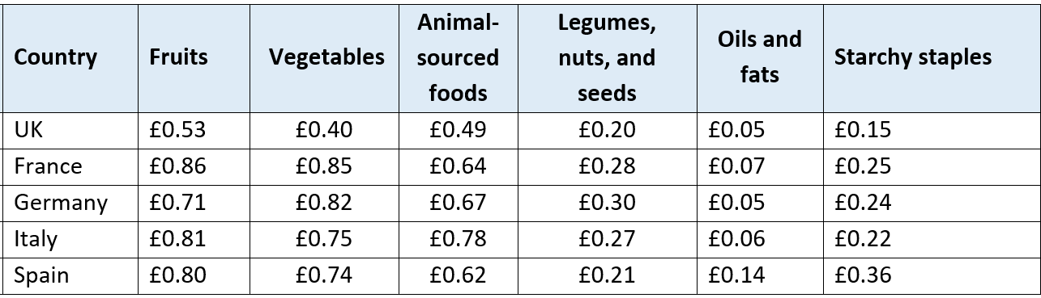

**Table 2:** Share of food groups in diet.

| **Country** | **Fruits** | **Vegetables** | **Animal - sourced foods** | **Legumes, nuts, and seeds** | **Oils and fats** | **Starchy Staples** |
| --- | --- | --- | --- | --- | --- | --- |
| UK | 29.3% | 21.9% | 10.7% | 27.1% | 2.9% | 8.1% |
| France | 29.3% | 28.9% | 9.4% | 21.8% | 2.2% | 8.4% |
| Germany | 25.6% | 29.3% | 10.8% | 23.9% | 1.9% | 8.5% |
| Italy | 28.1% | 26.0% | 9.2% | 27.0% | 2.0% | 7.7% |
| Spain | 29.5% | 27.4% | 7.8% | 23.1% | 2.0% | 10.2% |

# Assessment Task(s)

Design and build a console-based application that requires the user to enter the country and food groups data via the command line and store them in an appropriate internal data structure.

* There is no requirement for this data to be preserved after the application is closed.
* You will need to consider what the application outputs to the user that demonstrates the results of each task below.
* You should provide the user with the means to close the program once user operations are complete.

Your application should be able to perform the following tasks as given in Section II. (Scenario):

**Task A:** Write pseudocode algorithms for the tasks given below.

1. Input the cost data for each country's food group (fruits, vegetables, etc.) and store it in an appropriate data structure using Table 1.
2. Input the percentage data for each country's food data (fruits, vegetables, etc.) and store it in an appropriate data structure using Table 2.
3. Display the total cost of animal-sourced foods from the diet using Table 1.
4. Calculate and display the total cost of a healthy diet for each country using Table 1 and identify the minimum.
5. Sort the diet data of the five countries by the percentage share of fruits from maximum to minimum using Table 2.
6. Sort the diet data for Germany by the percentage share of each food group from maximum to minimum using Table 2.
7. Search the country input and find the cost of oils and fats for a healthy diet using Table 1 and also find the % share of the diet using Table 2.

Sample

| Input:  Enter the Country: France  Output:  The cost of oils and Fats: £0.07  The share of diet: 2.2% |
| --- |

1. Search one of the countries, then find the cost of the food groups and total cost in a least-cost healthy diet using Table 1 and 2.

Sample

| Input:  Enter the country: Italy  Output:  Least cost healthy diet-fruits: £ 0.81*28.1/100 = £0.22  Least cost healthy diet-vegetables: £ 0.75* 26/100 = £0.19  …  Total: £0.58 |
| --- |

**Task B:** Construct the application and implement algorithms.

**1.** Develop a single Java program that follows coding conventions and enables the user to search, sort, and provide the list of countries by using algorithms studied in this module, which are run from the command line. The application should be text-based and menu-driven.

**2.** Implement all the algorithms you have created for Task A.

Note:

* You need to ensure that the user input is validated, and feedback is given when an invalid input is entered.

● Test all the implemented algorithms you have created for Task A.

# Deliverables

This work is not submitted unless it is as a requirement of an exam question. You should complete as much of this work as you can during Week 8, as there will be no time during the exam (2 hours, plus 30 minutes for uploads) to do so. You should organise your work to ensure you can access this work during the exam quickly and easily.

# Marking Criteria

No marks are awarded directly for the exam pre-work. Where the exam pre-work is referred to, uploaded, or otherwise used in exam questions the marks will be made clear on the examination paper.

# Assessment Policies

This assessment is subject to the policies stated on the ‘Summative Assessment Policies’ page in Canvas. These policies include (but are not limited to):

* Academic Integrity and submission of student work to Turnitin
* Advice on anonymising your assessment
* Penalties for late submission
* Marking policy for multiple submissions
* The Fit to Sit / Submit policy
* Passing mark and module reassessment

Please ensure that you have read and understood these policies before starting the assessment.